AGRICULTURE CROP PRODUCTION IN INDIA (1997-2023)

  - PROJECT OVERVIEW
The Crop Production Analysis Dashboard is an interactive analytics project developed using Microsoft Excel and Power BI. The dashboard provides insights into crop production trends, state-wise performance, season-wise distribution, and yield analysis through interactive charts and visualizations. The project helps users understand agricultural data in a simple and visual format using KPI cards, graphs, slicers, and reports
  - OBJECTIVES
The main objective of this project is to analyze agricultural production data and convert raw data into meaningful insights. The project aims to compare crop production across states and years, identify production trends, analyze yield performance, and create interactive dashboards for better decision-making and data visualization.
  - DATASET INFORMATION
Source Description: India Data Portal
Timeline : 1997-2023
Domain : Agriculture Analytics
Number of Rows: 4,55,360
Number of Columns: 16

  - OBJECTIVES
- To analyze agricultural crop production data from different states and years.
- To identify crop production trends and yield performance.
- To compare state-wise and season-wise agricultural production.

  - ATTRIBUTE(COLUMN/ FEATURES) DETAILS

Attribute Name | Data Type | Description
State | String (Text) | Name of the state where crop production was recorded
District | String (Text) | Name of the district in the state
Crop Year | Numeric (Integer) | Year in which crop production data was recorded
Season | Categorical | Agricultural season such as Kharif, Rabi, Summer, Winter etc.
Crop | String (Text) | Name of the crop cultivated
Area | Numeric (Decimal) | Total cultivation area for the crop in hectares
Production | Numeric (Decimal) | Total crop production quantity in tonnes
Yield | Numeric (Decimal) | Production yield obtained from cultivation in tonnes/hectare
Production Level | Categorical | Category representing Low, Medium, or High production
Start Year | Numeric (Integer) | Extracted starting year from crop year column for trend analysis

  - TOOLS & TECHNOLOGIES
Microsoft Excel: Data Cleaning, preprocessing and pivot tables
Power BI: Dax functions, dashboard creation and data visualization
  - DATA PRE-PROCESSING (EXCEL/POWER QUERY)
Tasks Performed:
Data Cleaning & Transformation:
Removed duplicates, corrected data types, renamed column headers, created production level category, filtered unnecessary data, cleaned inconsistent values for better analysis
Filtering & Sorting:
Applied filters to remove unwanted and blank records, sorted production values in ascending and descending order
Pivot Table and Chart:
Created pivot tables to summarize agricultural data, used pivot charts for quick visual analysis.

  - DATA MODELING AND DAX FUNCTIONS (POWER BI)
Data Model :
The project was developed using a single cleaned dataset. The dataset was maintained in a denormalized single-table structure for simplified reporting and dashboard development in Power BI.
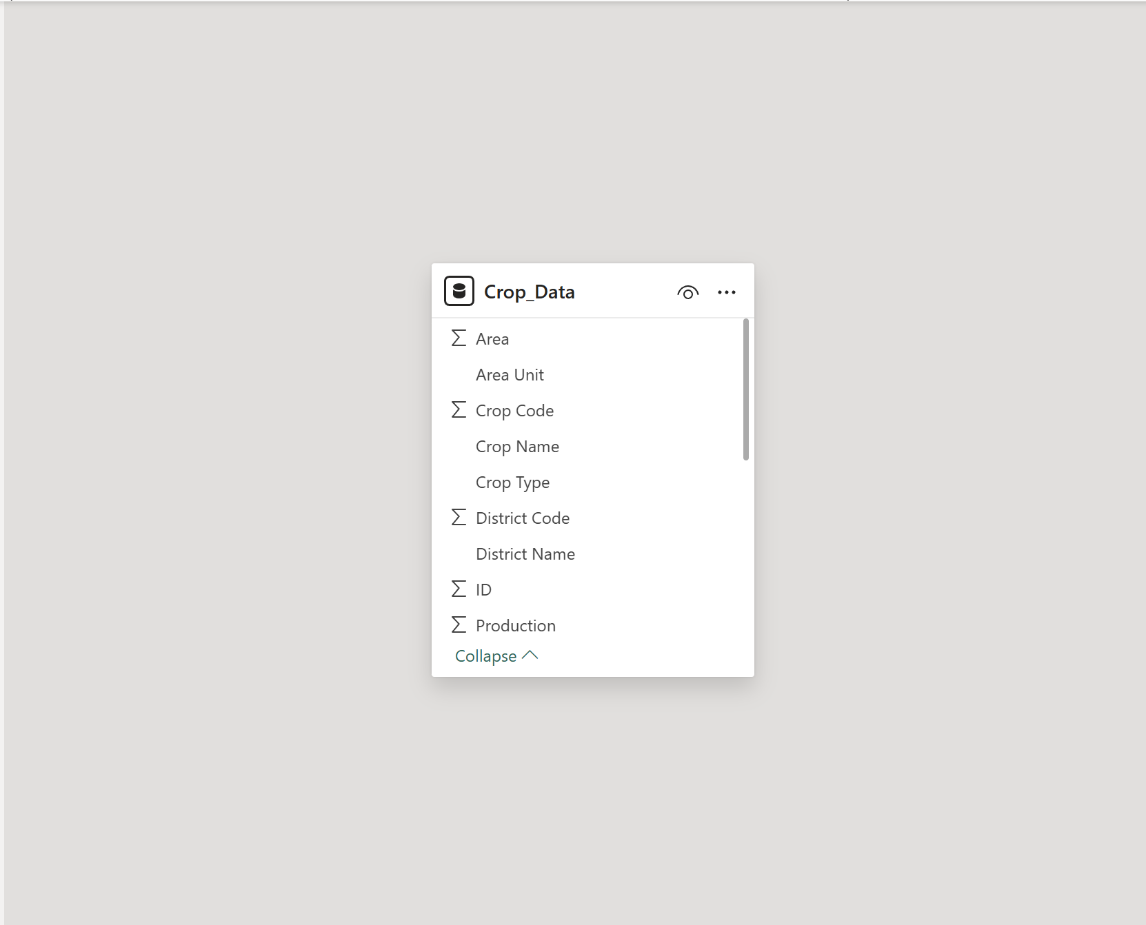

Calculated Columns / Measures:
Implemented DAX formulas for key metric such as total production , total area and total yield
Got it. No tables. Here’s the same documentation in simple paragraph + bullet format.
Analysis and Visualizations (Power BI)
The cleaned agricultural production dataset was imported into Power BI Desktop to develop an interactive dashboard for crop production analysis. The objective was to create a consolidated report with multiple visualizations, interactive features, and clear communication of insights as per project requirements.

Dashboard Features Implemented
Multiple Visualizations Based on Problem Statement
Four primary visualization types were implemented to address the problem statement:
Card Visuals were used to display key performance indicators at a glance. The dashboard includes cards for TOTAL PRODUCTION, TOTAL YIELD, TOTAL AREA, and CROP COUNT.
Bar Chart titled `Production Level Distribution` was used to compare total production levels across different categories like Medium, Low, and High.
Line Chart titled `Production Trend by Year` was used to analyze trends in crop production over time and identify yearly patterns.
Donut Charts were used to show percentage shares. These include `Production Share by Season` and `Production by Crop Type` to analyze contribution of each season and crop category.
Interactive Layout Using Filters and Slicers
Filters: A top N filter was applied to focus the analysis on the most significant data points. This was used to display only top performing states or crops by production, preventing visual clutter and highlighting key insights
Slicers: The `State` slicer enables filtering of the entire dashboard by one or more geographic states. The `Crop Type` slicer allows users to filter visuals by specific crop categories such as Cereals, Fruits, and Oilseeds.
Bookmarks, Titles & Labels
Bookmarks: Two bookmarks were configured and made accessible via buttons on the dashboard. The `Overall View` button clears all active slicer selections to display consolidated national-level data. The `State View` button applies the selected state filter for focused analysis. These buttons are prominently placed for one-click user interaction.
Clear Titles: Each visualization has a clear, descriptive title that communicates its purpose. Examples include TOTAL PRODUCTION, Production Trend by Year, State, and Crop Type. This ensures the dashboard is self-explanatory.
Labels: Data labels are enabled on all applicable visuals for clarity. KPI cards display large callout values like 374.8 bn Tonnes. The Production Level Distribution bar chart includes Y-axis labels indicating production values. The Production Trend by Year line chart displays axis labels for year and production volume. This ensures exact metric values are communicated without user interaction.

Consolidated Report / Dashboard
All components including KPI cards, slicers, charts, and bookmark navigation buttons are consolidated into a single-page dashboard titled `CROP YIELD AND PRODUCTION ANALYSIS`. This provides a comprehensive view for stakeholders to analyze crop production data from national overview down to state and crop-type specific details.
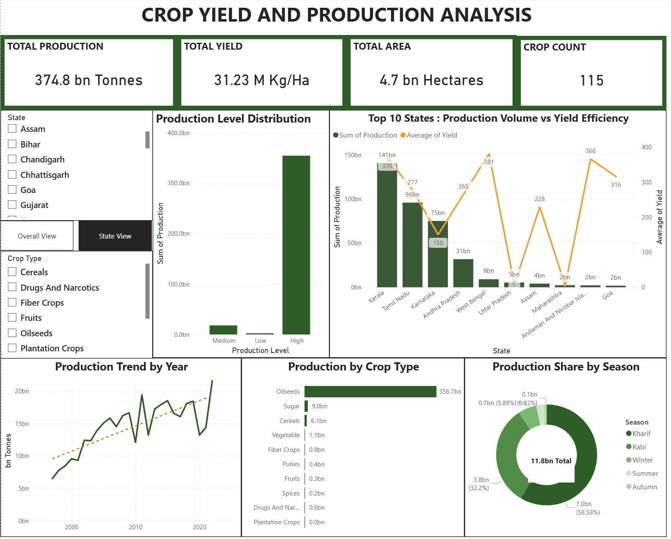
  - INSIGHTS
  - Key Findings
The analysis shows that crop production varies across different states, crop types, and seasons in India. Production trends have generally increased over the years, while seasonal factors play a major role in agricultural output. The dashboard also highlights that some states achieve high production volumes but comparatively lower yield efficiency. In addition, the majority of records fall under the medium production category, helping identify overall agricultural production patterns and performance.

  - Descriptive Analytics
This level summarizes historical data to understand past performance.
Total Production: The dataset recorded a total agricultural production of 374.8 Billion Tonnes across the analysis period.
Crop Composition: Oilseeds was the dominant crop type with 356.7 Billion Tonnes , accounting for 95.2% of total production. The other 9 crop types combined contributed only 4.8%.
Geographic Concentration: Madhya Pradesh emerged as the top-producing state with 188.4 Billion Tonnes, contributing over 50% of national output. The top 10 states account for approximately 90% of total production.
Temporal Patterns: The `Production Trend by Year` visual indicates significant year-on-year fluctuations in production volume, with peaks and troughs corresponding to seasonal and climatic variations.
  - Diagnostic Analytics
This level investigates the reasons behind the observed trends and patterns.
Reason for Oilseed Dominance: The high volume of Oilseeds is attributed to large-scale cultivation in states like Madhya Pradesh, supported by favourable agro-climatic conditions, established MSP policies, and extensive farming area allocated to these crops.
Reason for State Disparity: The dominance of Madhya Pradesh is due to its large agricultural land area, soil suitability for Oilseeds, and strong irrigation infrastructure. Lower-producing states are constrained by factors like smaller landholdings, water scarcity, or focus on non-cereal crops.
Reason for Yearly Variation: Fluctuations in the yearly trend are primarily driven by external factors such as monsoon variability, drought conditions, pest outbreaks, and changes in government procurement policies.
  - Predictive Analytics
This level uses historical patterns to forecast future outcomes. Based on current trends:
Production Forecast: If current growth patterns continue, total production is likely to maintain an upward trajectory but remain vulnerable to annual drops during poor monsoon years. Oilseeds will likely continue to dominate unless crop diversification policies are implemented.
Risk Prediction: States with high dependency on a single crop type face a higher risk of production loss due to crop-specific diseases or market price crashes. Continued reliance on Madhya Pradesh poses a supply-chain risk if that region faces adverse weather.
Yield Prediction: Without intervention in lower-performing states, the production gap between top and bottom states is predicted to widen further over the next 5 years.

  - Prescriptive Analytics
This level recommends actions based on the analysis to drive outcomes.
Promote Crop Diversification: Government and agricultural bodies should incentivize cultivation of non-Oilseed crops in high-production states to reduce monoculture risk and improve nutritional security.
Targeted Resource Allocation: Investment in irrigation, technology, and high-yield seeds should be directed toward states with low production but high agricultural potential to balance regional disparity.
Implement Early Warning Systems: Integrate weather forecasting data with this dashboard to create predictive alerts for potential production drops, enabling pre-emptive action like crop insurance drives or water management.
Replicate Best Practices: Conduct a detailed study of farming practices in top-performing districts of Madhya Pradesh. The drill-down capability of this dashboard can identify these micro-regions for knowledge transfer programs.
  - CONCLUSION
The agricultural crop production analysis successfully identified important trends and patterns across different states, crop types, seasons, and years. The study helped in understanding variations in production and yield, along with identifying high-performing crops and regions.
Through interactive analysis and visualization, the project simplified complex agricultural data into meaningful insights that are easier to interpret and compare. The findings of this analysis can support better understanding of agricultural performance and assist in data-driven evaluation of crop production trends.
Overall, the project demonstrated how data analysis can be used to convert raw agricultural data into valuable information for reporting and analytical decision-making.

